**Experiment name :** Write a simple matlab program to perform general procedure of Amplitude modulation and demodulation .

**Objective :**

Objective is to perform amplitude modulation for a message signal and demodulate the signal and recover the message signal .

**Code :**

clear all;

clc;

fs=2000;

fm=5;

fc=250;

n=2000;

t=(1:n)/fs;

wn=0.02;

[b,a]=butter(2,wn);

w=(1:n)*2*pi*fc/fs;%normalization

w1=(1:n)*2*pi*fm/fs;

vc=sin(w); %carrier

vsig=sawtooth(w1,0.5);%0.5 is filter coefficient

vm=(1+0.5*vsig).*vc;

%msg signal

subplot(5,1,1);

plot(t,vsig,'k');

title('maasge signal');

%carrier signal

subplot(5,1,2);

plot(t,vc,'g');

title('carrersignal');

%modulated

subplot(5,1,3);

plot(t,vm,'m');

title('modulatedsignla');

noise=randn(1,n);

scale=(var(vsig)/var(noise))*3.16;

vm=vm+noise*scale;%noise signal

%noise

subplot(5,1,4);

plot(t,vm,'r');

title('noisesignal');

ishift=fix(0.125*fs/fc);

vc=[vc(ishift:n) vc(1:ishift-1)];

v1=vc.*vm;

vout=filter(b,a,v1);

%recovered

subplot(5,1,5);

plot(t,vout,'c');

**Output :**

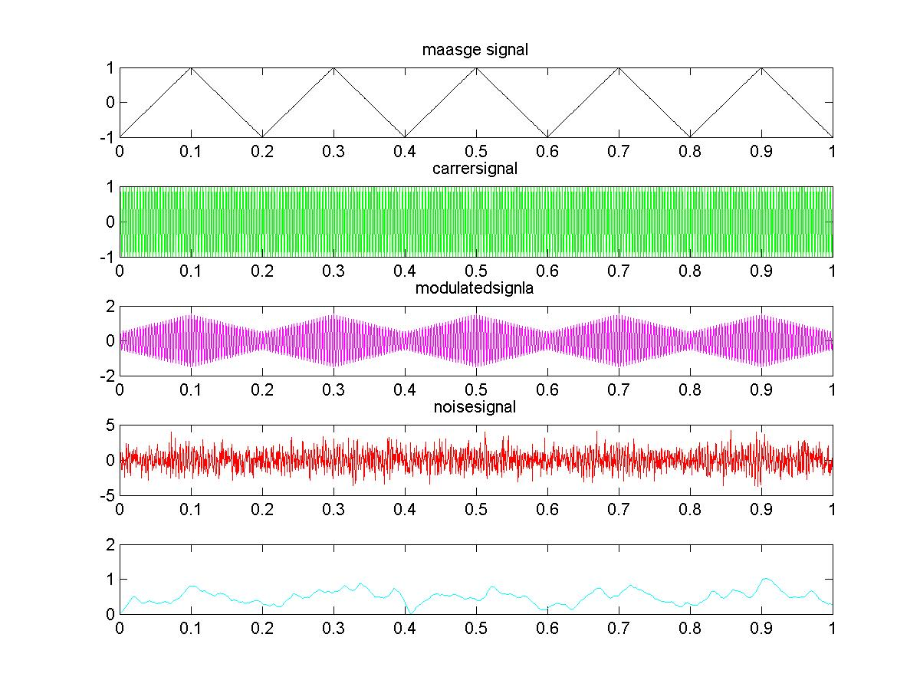

**Conclusion :**

In this lab we learnt how to perform amplitude modulation for a message signal using a carrier signal .And recover the signal again or in other words demodulate the signal , we learnt the what noise is and how it effects on the output . This lab will be of great help in the upcoming labs .